**Disaster Management**

**Assignment 5**

**QGIS – Raster Analysis**

Shivani Chepuri

2018122004

**Q1 – Data Downloading**

The data is downloaded from USGS Earth Explorer (logged in)

**Link:** <https://earthexplorer.usgs.gov/>

**Google Drive Link for .TIF images:** <https://drive.google.com/open?id=1q1dD2vx2yEZTx8xPDpN20vZ5U8vqKe_2>

**Data Type:** Landsat 7 ETM+ C1 Level 1

**Data ID:** LE07_L1TP_144047_20000229_20170213_01_T1

**Data Acquisition Date:** 29-FEB-00 (by satellite - Data time scale)

**Path:** 144

**Row:** 47

**Area:** Telangana, India

**Data set Downloading:**

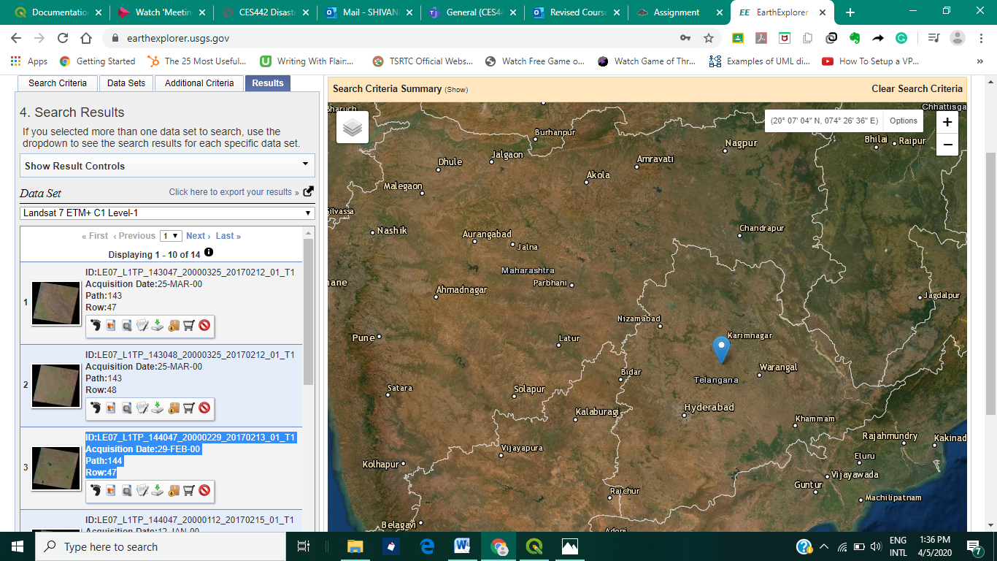

**Q2**

TCC and FCC – True Color Composition and False Color Composition

**Merging Bands:**

Each band has pixels with values ranging from 0-255, representing intensity values.

Each band is assigned a color – say instead of gradations of black and white, in a red band, we have gradations of red color.

The Landsat Data has 7 bands. They are in the order Blue, Green, Red, Near Infrared, Infrared, Shortwave Infrared, Thermal Infrared and Panchromatic. B, G, R bands are in the visible range.

To obtain True Color composite, we need Blue, Green and Red components of an image. Therefore, merge the first three bands for **TCC**

**Original Merged Image: 4 bands**

Red (Band 1), Green (Band 2), Blue (Band 3) -Default

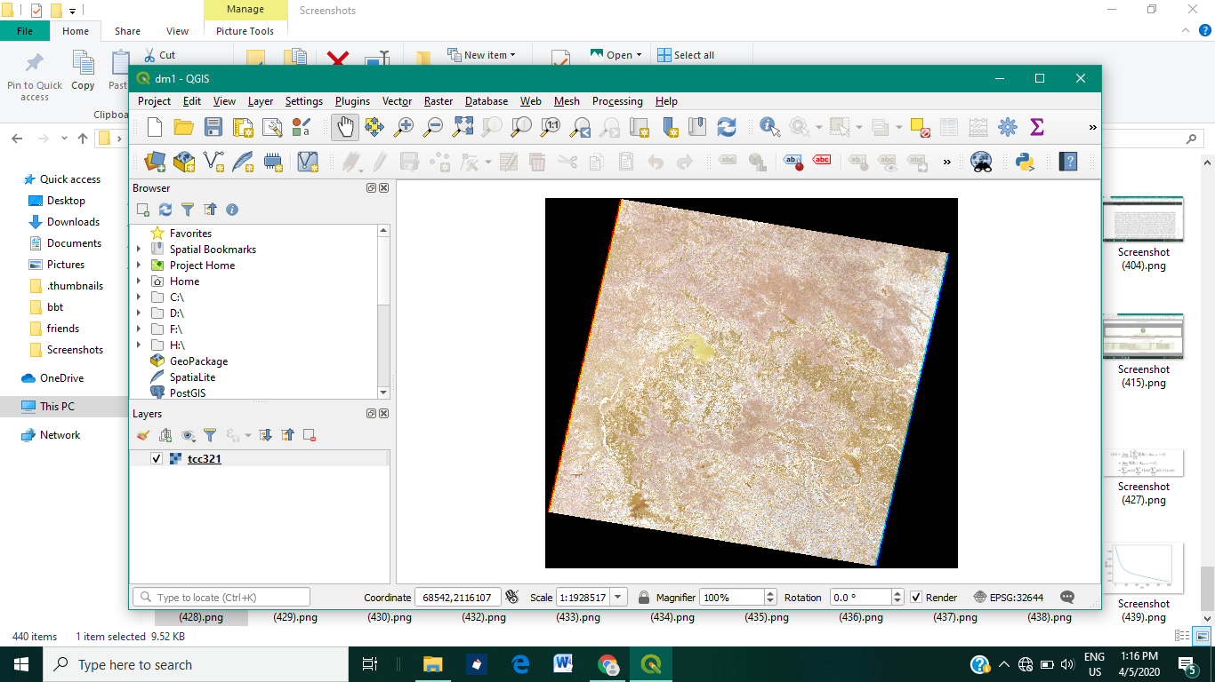

**TCC**

Merged Output of Red (Band 3), Green (Band 2), Blue (Band 1) is as follows:

Oversampling value = 2.00

**Before Enhancing**

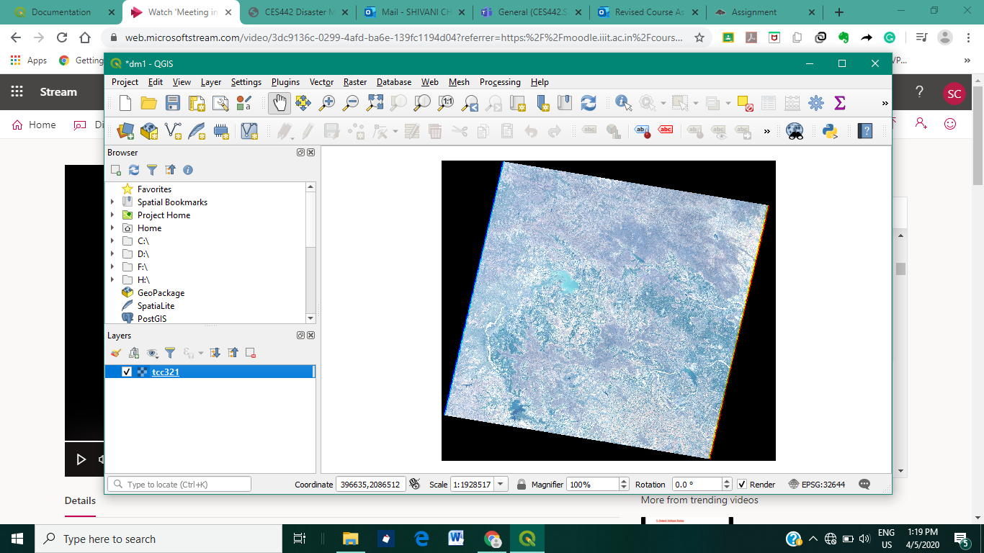

**After Enhancing**

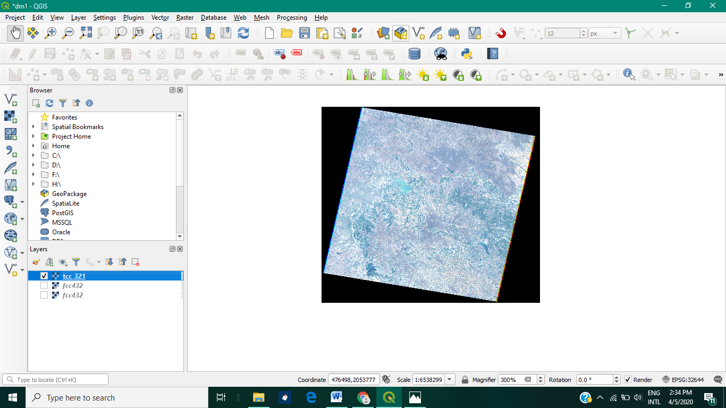

By changing intensity, contrast, saturation and such parameters, the merged image can be visualized in different ways.

**1. FCC**

Merged Output of Red (Band 4), Green (Band 3), Blue (Band 2) is as follows: Oversampling value = 2.00

**FCC 432 - Before Enhancing**

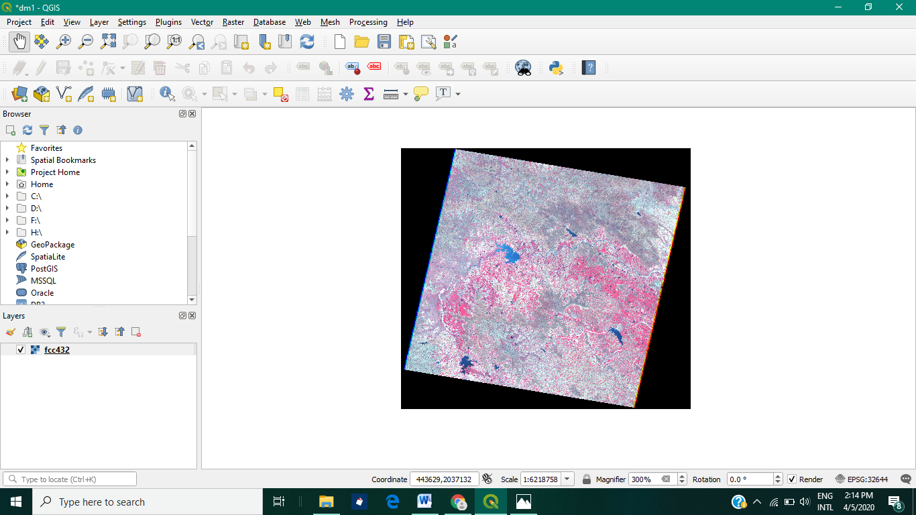

**FCC 432 - After Enhancing**

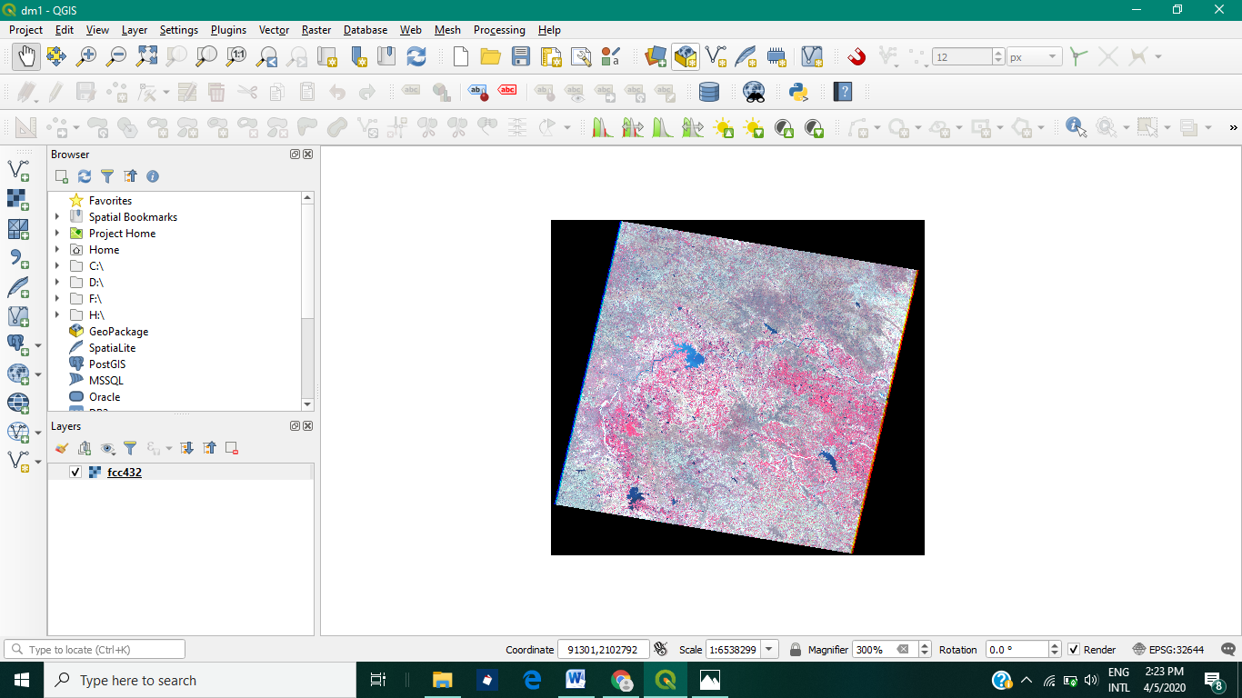

By changing intensity, contrast, saturation and such parameters, the merged image can be visualized in different ways. Oversampling value = 2.00

**2. FCC 431**

**Before Enhancing**

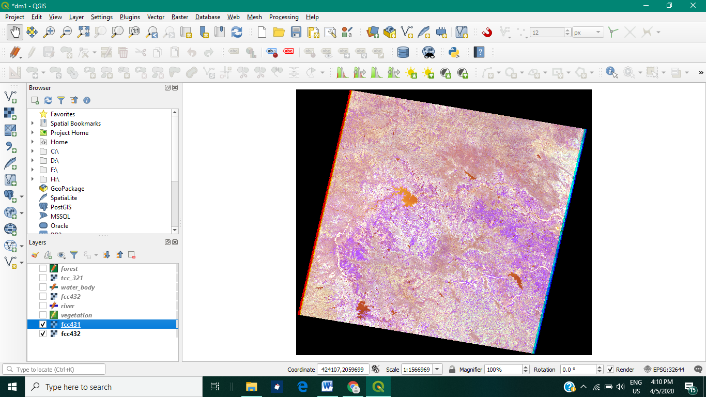

**After Enhancing**

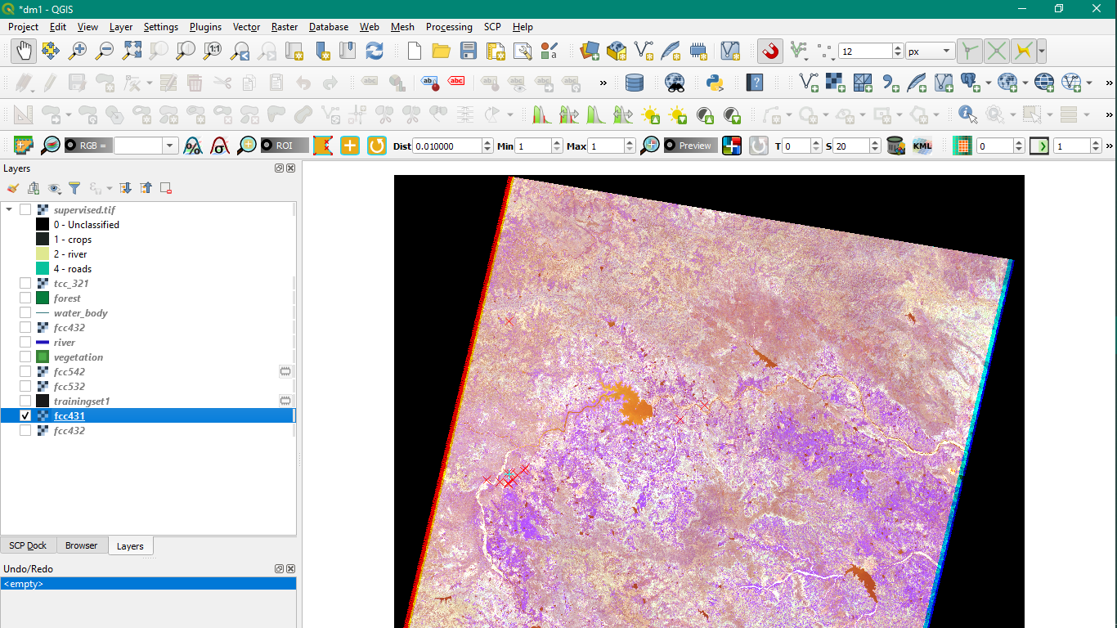

**5 Bands Merged Image:**

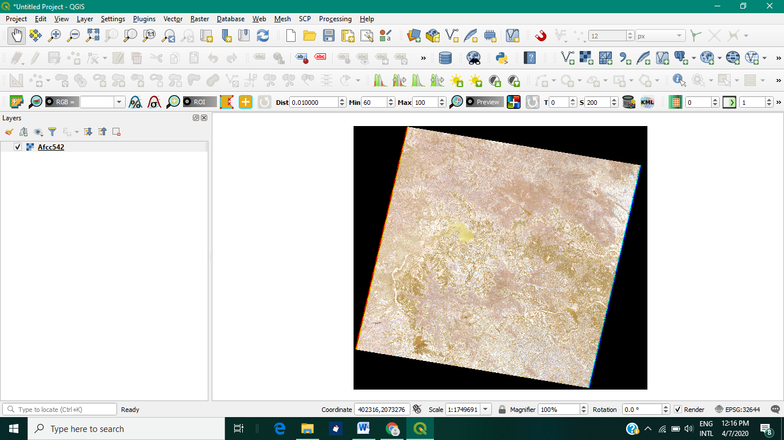

**3. FCC 542**

**Before Enhancing**

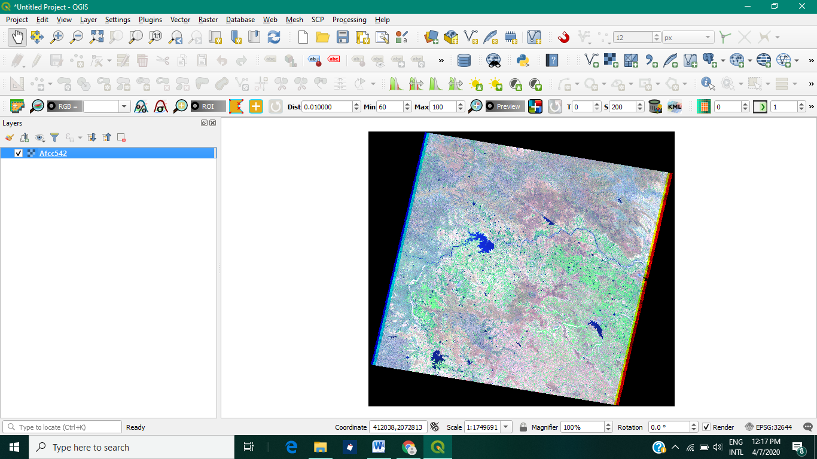

**After Enhancing**

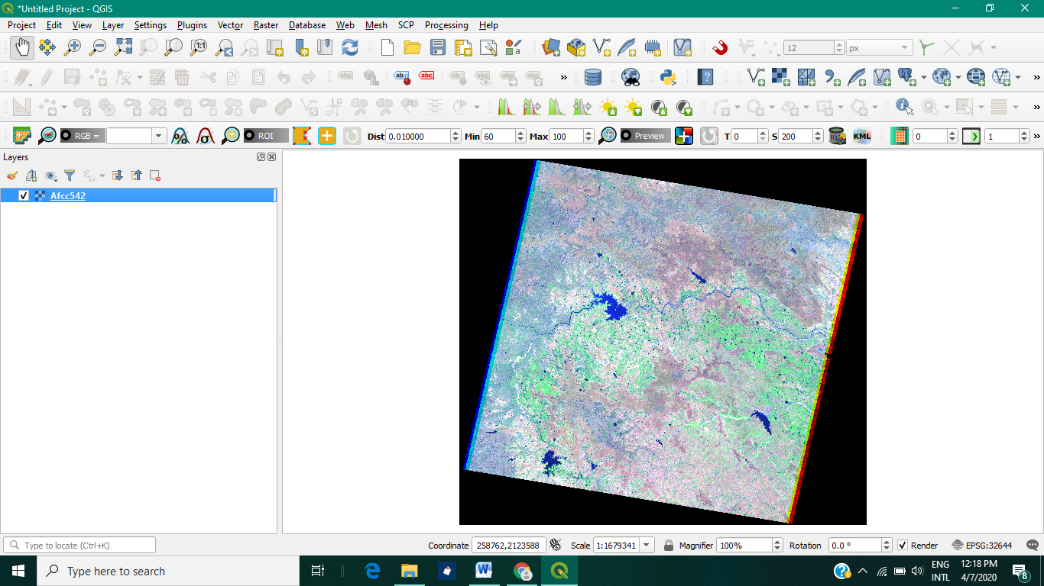

**4. FCC 532**

**Before Enhancing**

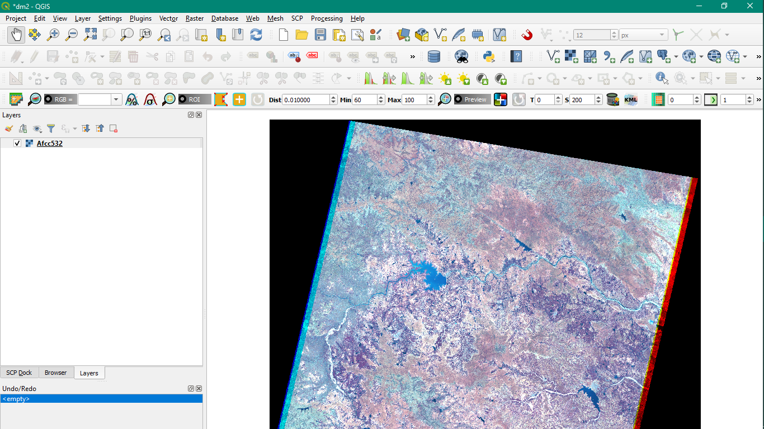

**After Enhancing**

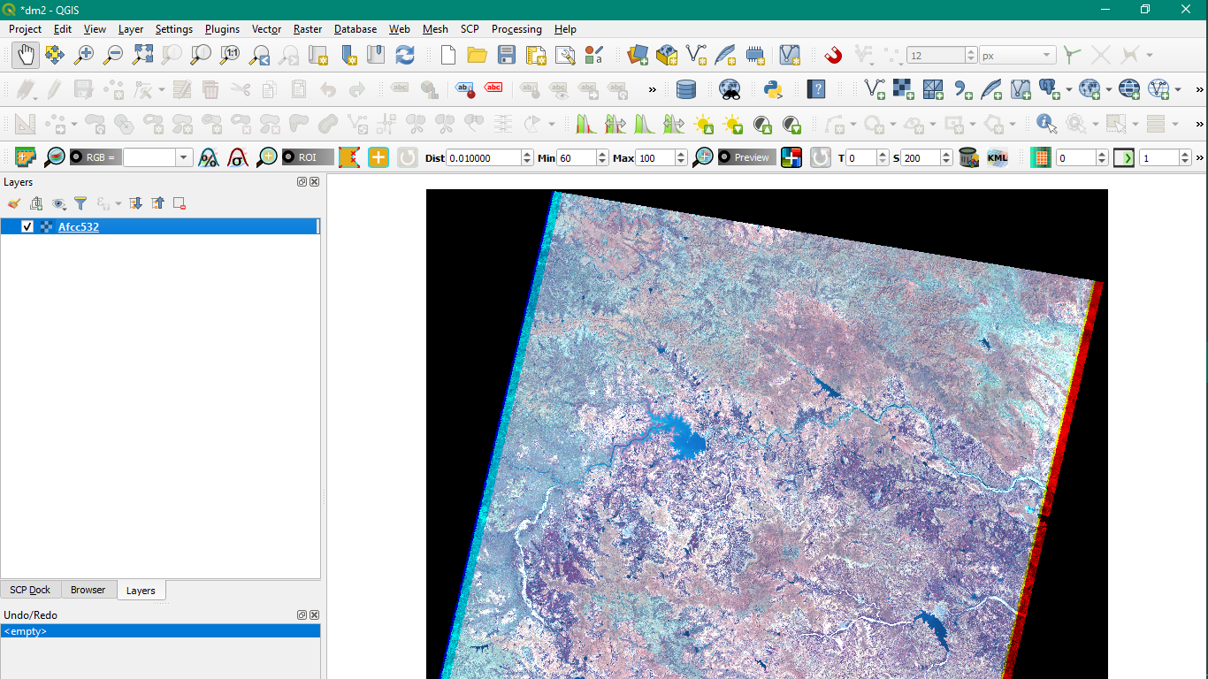

**Q3 – Layers : Done on FCC431 and FCC432**

**Fcc431 with vegetation, river and forest layers:**

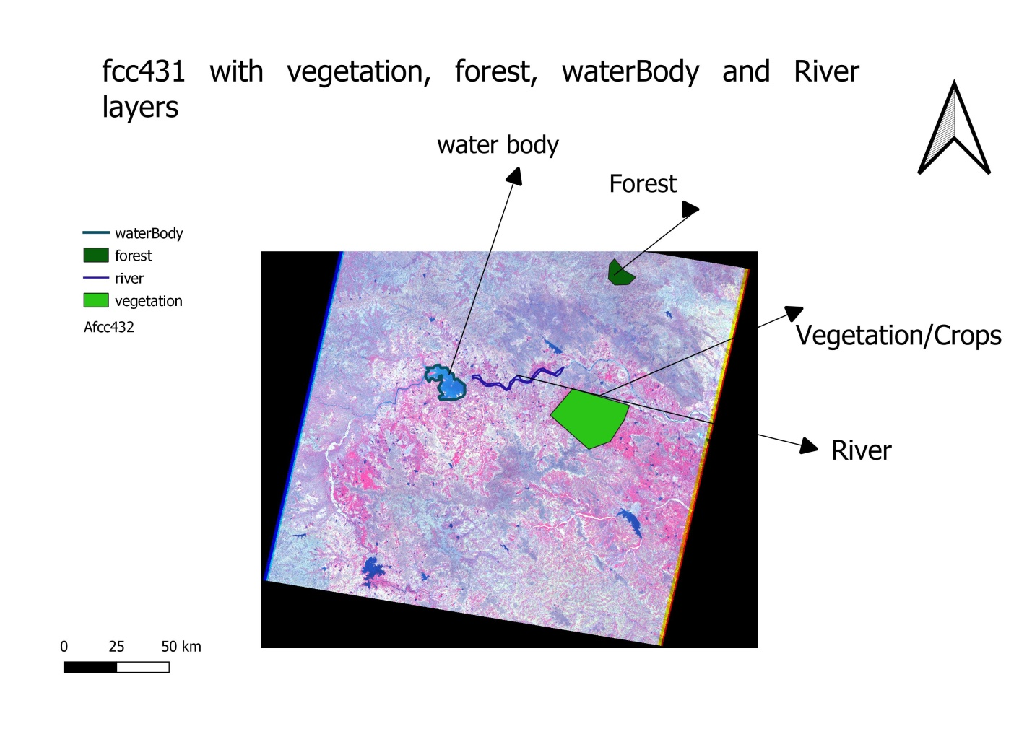

**Vegetation, River, Water Body, Forest layers - Layout Image:**

**FCC 432**

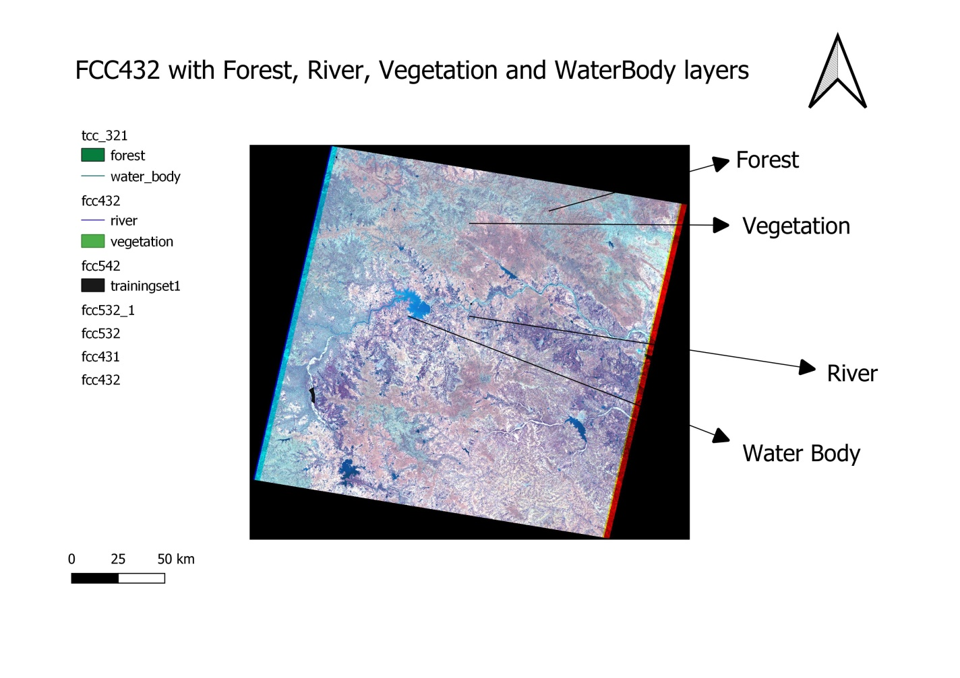

**Zoomed layout version highlighting the layers**

**(The layers were not selected in the layers panel in the above image – therefore, not visible. Please find them in another layout image attached below)**

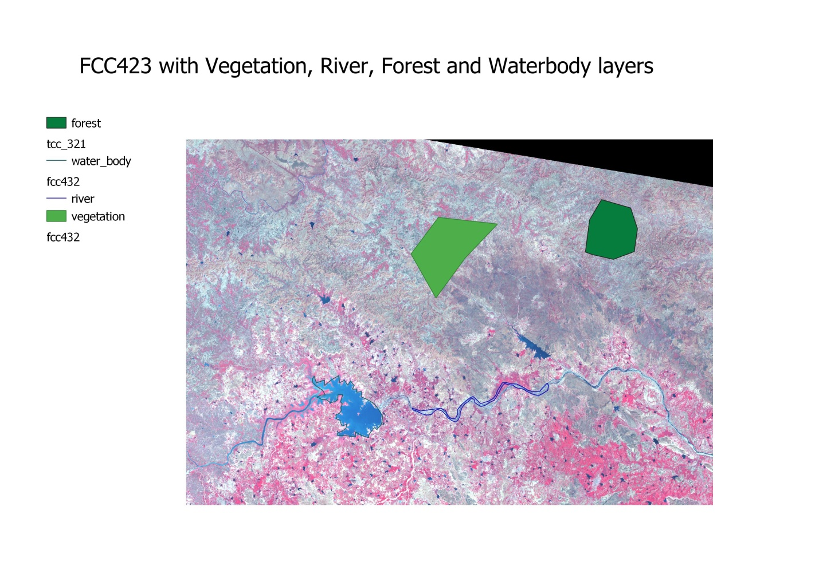

**Q4 - Unsupervised Learning:**

1. **K-means Clustering:**

**Number of classes =3, Number of Iterations=1**

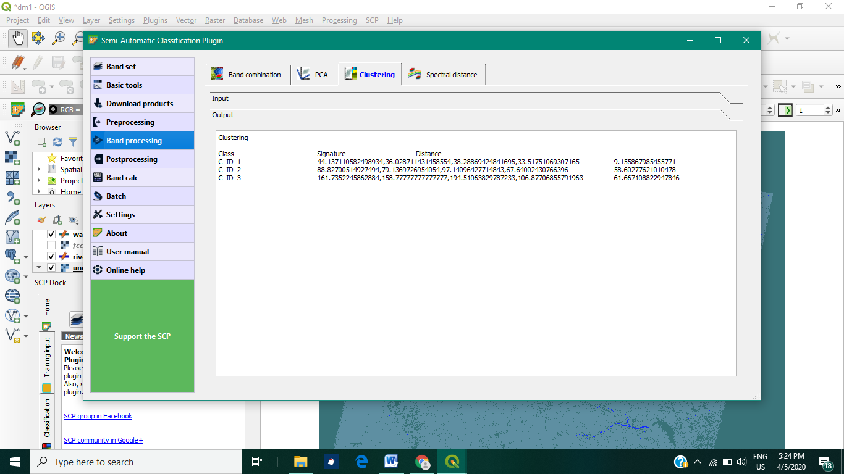

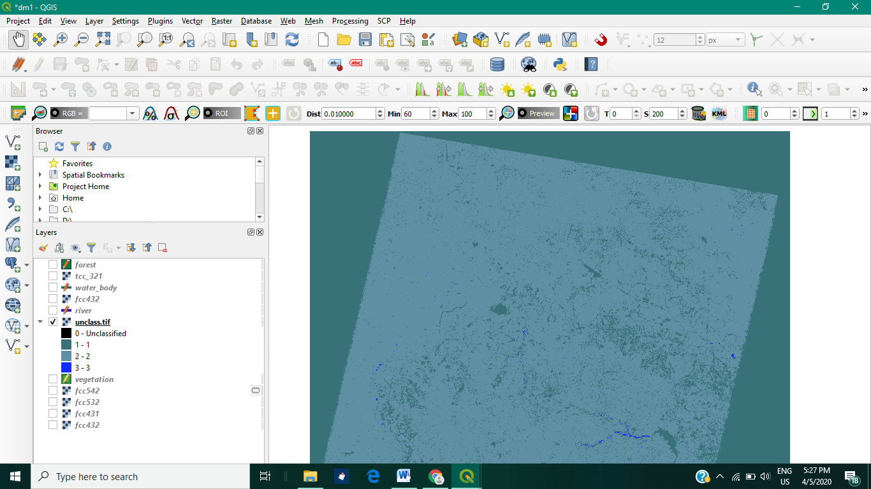

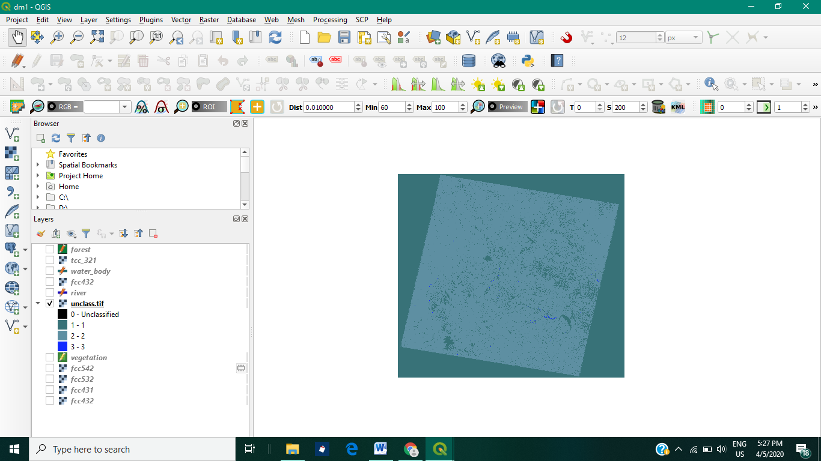

**Kmeans example 2: Iterations = 2**

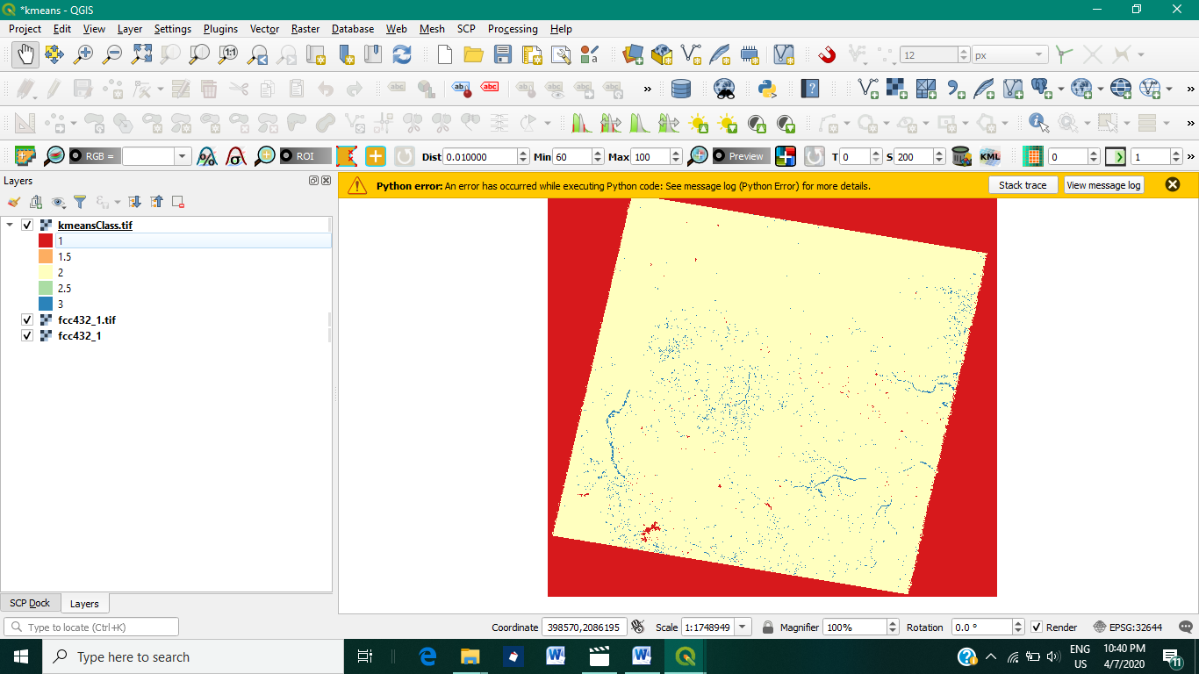

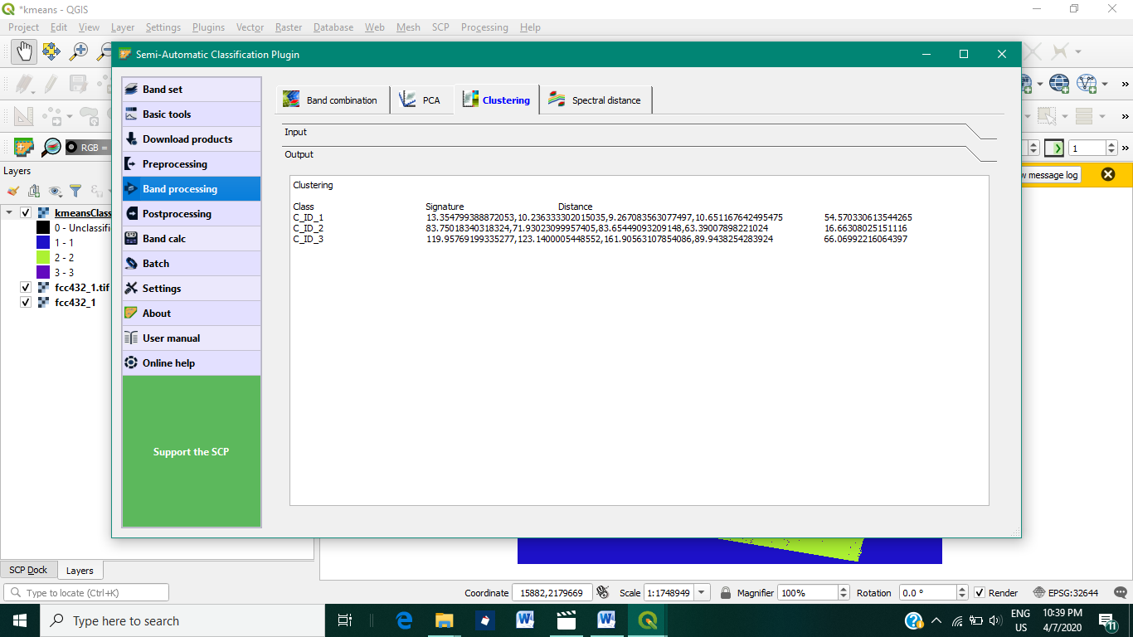

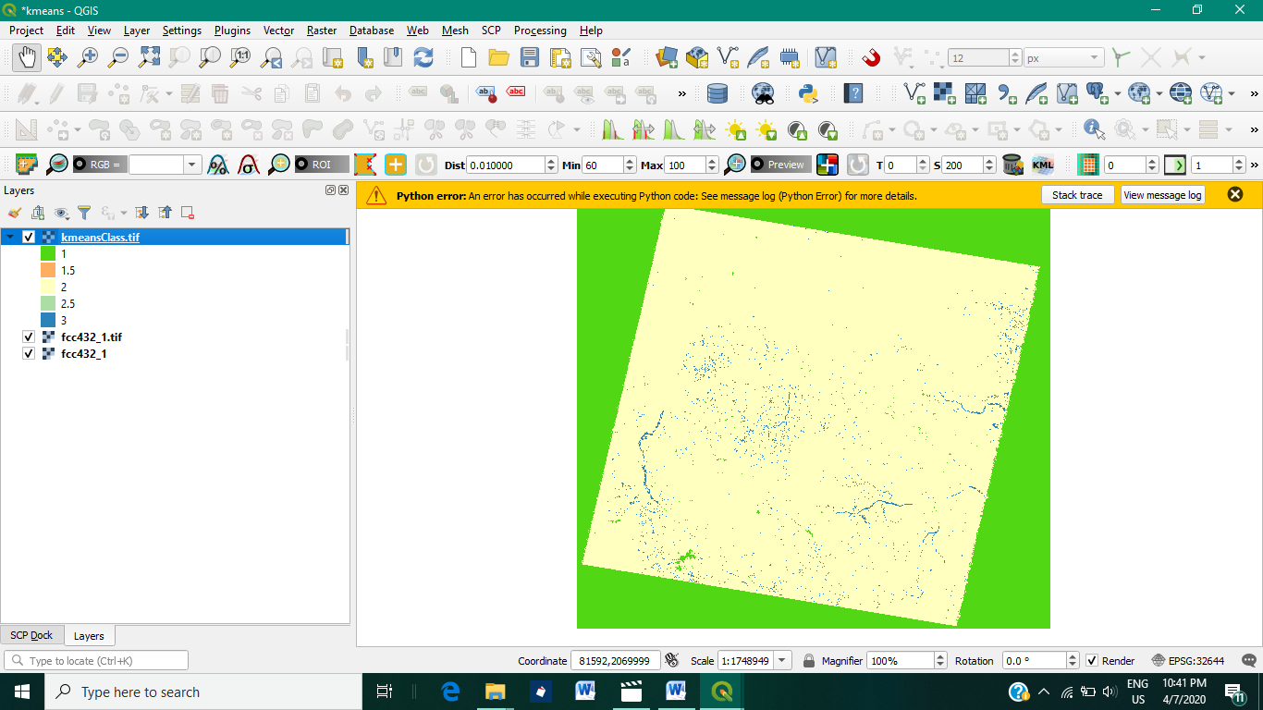

**Unsupervised Learning:**

1. **Isodata Algorithm: Iterations = 2**

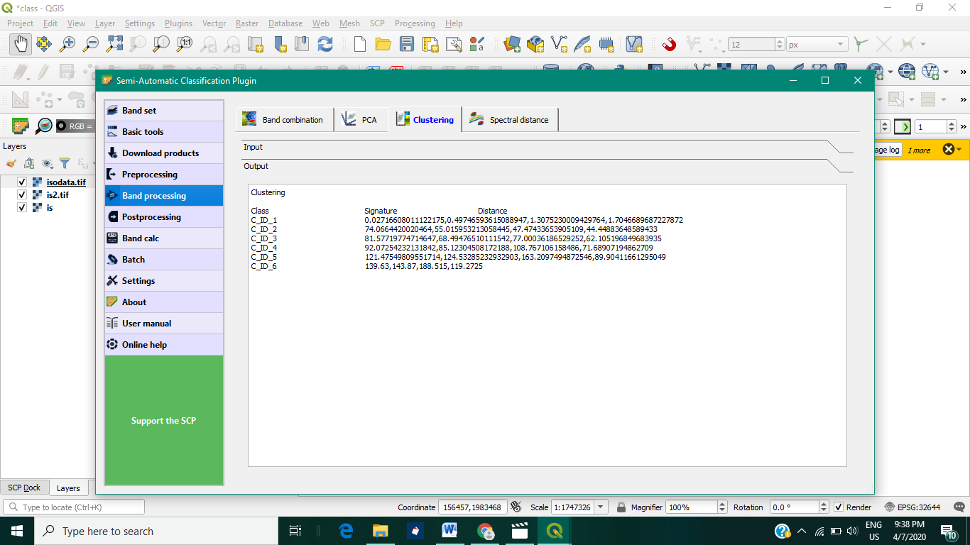

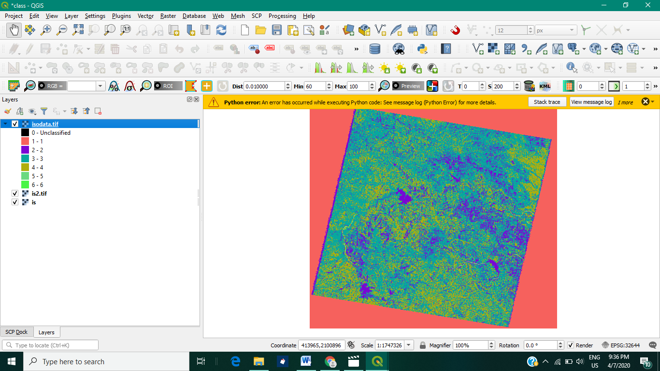

**Q5 - Supervised Learning:**

1. **Maximum Likelihood Algorithm**

**No. of classes = 4**

**Crops, River, Roads, Unclassified**

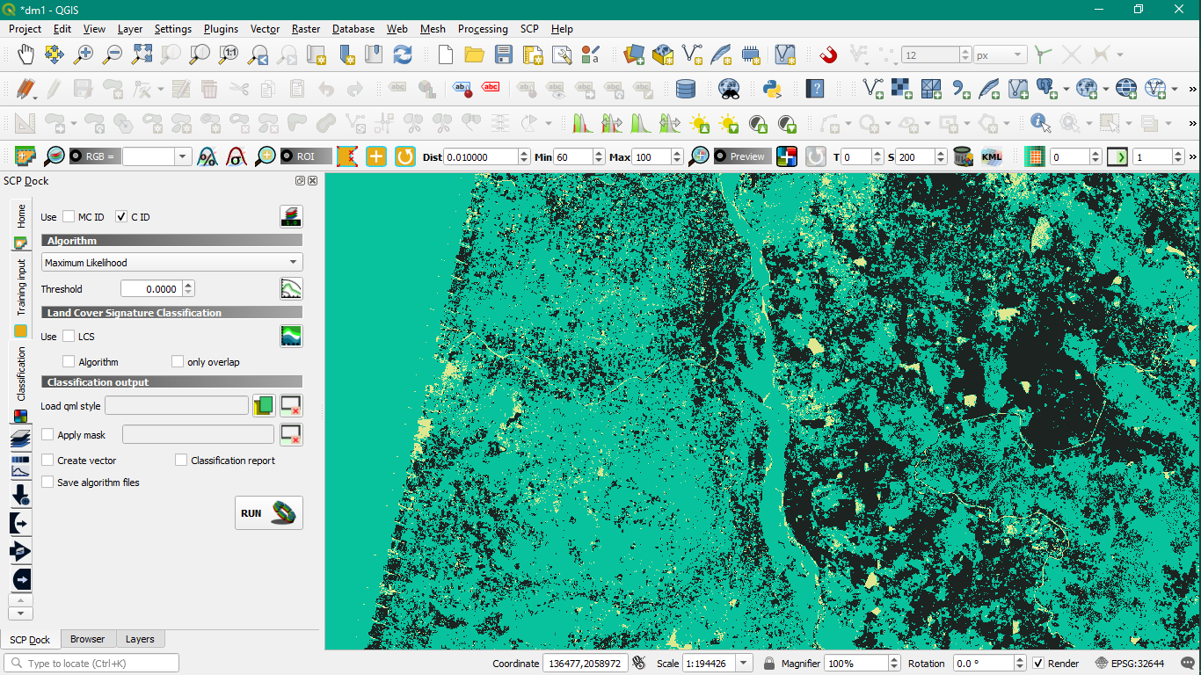

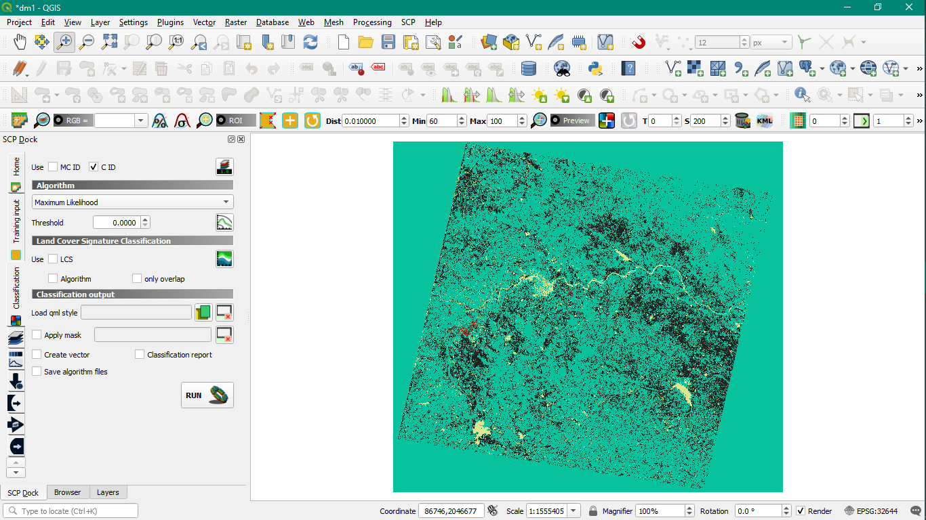

1. **Maximum Likelihood Algorithm**

**No. of classes = 6**

**Crops/Vegetation, River, Forest, Roads, water body, Buildings, unclassified**

**Supervised Trained sets – ROI Polygon**

